What is a flight controller?

* Central circuit of drone that houses the sensors to detect drone movement (accelerometer, gyroscope), controls speeds of motors (Note ESC’s still exist for each motor)

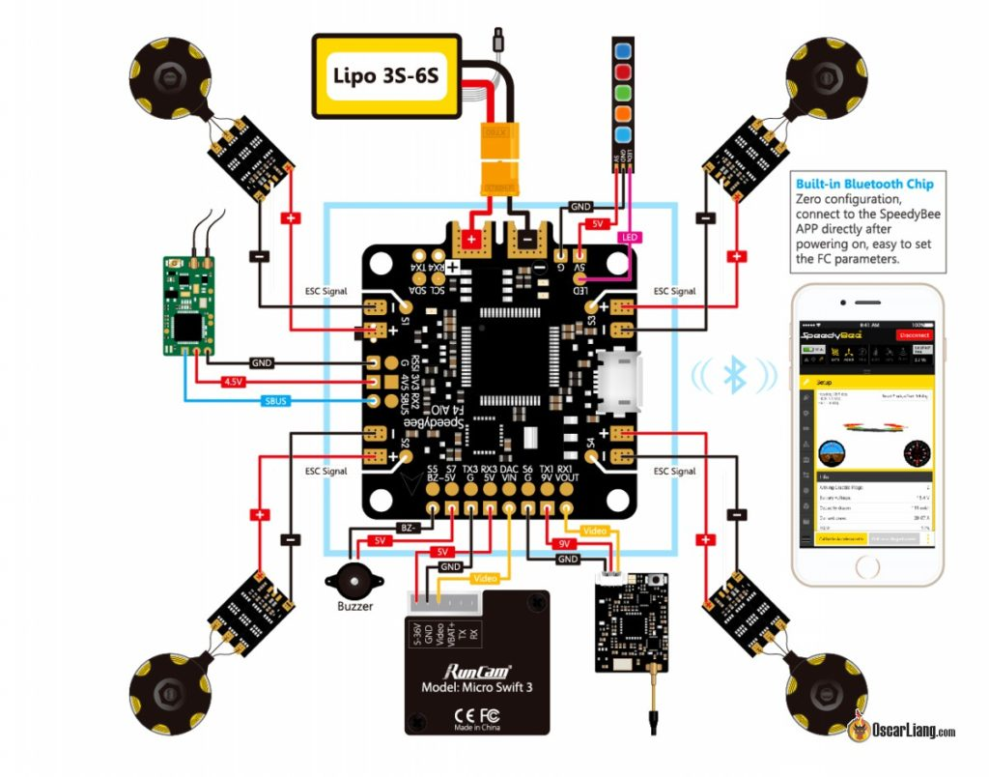

Flight Controller Firmware

* Ex. BetaFlight, KISS, FlightOne FalcoX, EmuFlight, iNav, ArduPilot

Flight Controller Processor

* Ex. F1, F3, F4, F7, H7
* MCU (Micro Controller Units)
* **F7**: 216 MHz Speed, 1MB Memory
  + STM32 (32 Bit ARM Processor)
  + 5-6 UART

UART

* Universal Asynchronous Receiver/Transmitter
* Hardware Serial Interface
  + Serial : sending data sequentially in bits
* Responsible for connections to radio, race transponder, VTX (FPV Visual Transmitter)
* TX and RX pins

IMU

* Inertial Measurement Unit
* Contains Gyro and Accel

Pix Hawk

* (Mini) barely larger than most F7 Builds
* (Mini) Similar specs
* PX4 - advanced autopilot
* Offer onboard Rasp Pi computation as secondary computer?